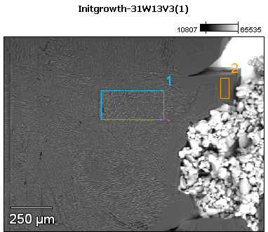

Image Name: Initgrowth-31W13V3(1)

Image Resolution: 512 by 384

Image Pixel Size: 3.09 µm

Acc. Voltage: 13.0 kV

Magnification: 80

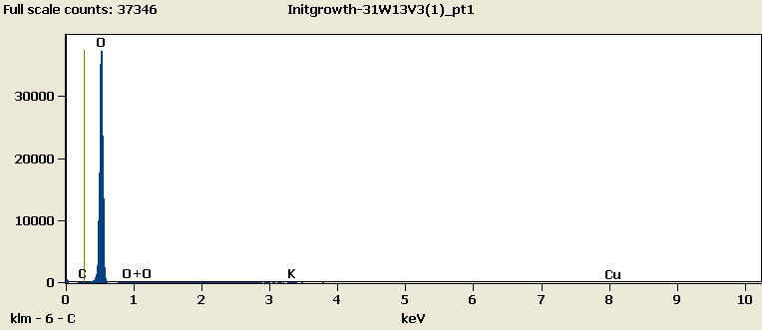

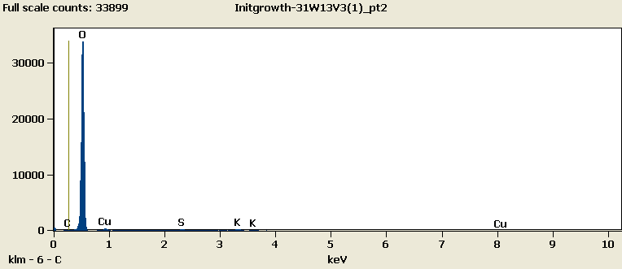

Weight %

|  |  |  |  |  |  |
| --- | --- | --- | --- | --- | --- |
|  | ***C-K*** | ***O-K*** | ***S-K*** | ***K-K*** | ***Cu-L*** |
| ***Initgrowth-31W13V3(1)_pt1*** | 0.00 | 95.45 |  | 0.28 | 4.26 |
| ***Initgrowth-31W13V3(1)_pt2*** | 0.11 | 89.58 | 0.97 | 1.89 | 7.46 |

Weight % Error (+/- 1 Sigma)

|  |  |  |  |  |  |
| --- | --- | --- | --- | --- | --- |
|  | ***C-K*** | ***O-K*** | ***S-K*** | ***K-K*** | ***Cu-L*** |
| ***Initgrowth-31W13V3(1)_pt1*** | ±0.00 | ±0.30 |  | ±0.04 | ±0.20 |
| ***Initgrowth-31W13V3(1)_pt2*** | ±0.08 | ±0.29 | ±0.07 | ±0.09 | ±0.18 |

# Cations

|  |  |  |  |  |  |
| --- | --- | --- | --- | --- | --- |
|  | ***C-K*** | ***O-K*** | ***S-K*** | ***K-K*** | ***Cu-L*** |
| ***Initgrowth-31W13V3(1)_pt1*** | 0.00 | 0.00 |  | 0.00 | 0.00 |
| ***Initgrowth-31W13V3(1)_pt2*** | 0.00 | 0.00 | 0.00 | 0.00 | 0.00 |